**How to check Logs in UNIX**

**EFMS GUI URLs:**

* EFMS-DATA- http://efms.it.att.com/efms/html/Default.html
* EFMS-MS- http://efmsms.it.att.com:8008/ms
* EFMS- PM (Networx) - http://efmspm.it.att.com/cc/common/ProfileLoginPage.jhtml
* EFMS-PM (SBS) - <http://efmspm.it.att.com/pm/index.do>
* EFMS-PM (BPC) : <http://efmswb00.it.att.com:9081/bpc/index.jsp>

**Servers for Putty:**

* ssh asprd246.aldc.att.com
* /usr/localcw/bin/sudo su - m67007

/usr/localcw/bin/sudo su - prodsupp

**Paths for logs:**

**BVOIP :**  /opt/project/log/bvoip

**Solution CR** : /opt/project/log/ms/ws

**MIS:** /opt/project/log/ms

**ss**

**Path For Old logs:**

/opt/app/pre_sales_files/oldlogs/LOG/MS_LOG/2018/11/02

gzgrep solution number *handler*

gzcat [File name] |less

**Note:**

* Change the date accordingly.

**Steps to fetch logs:**

* **Archived Logs:**

1. Enter the path in Prodsupp.

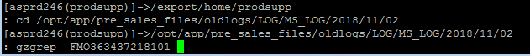

1. Copy the File name and enter as

gzcat [File name] |less

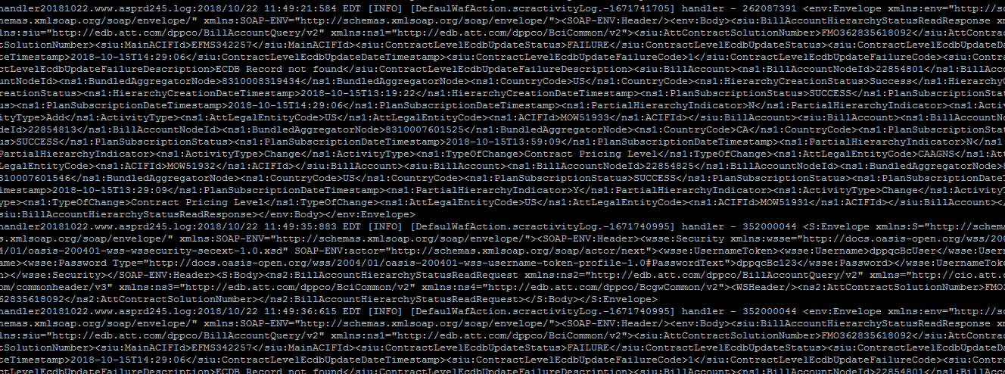

3. Search for the solution number as :

/ solution number

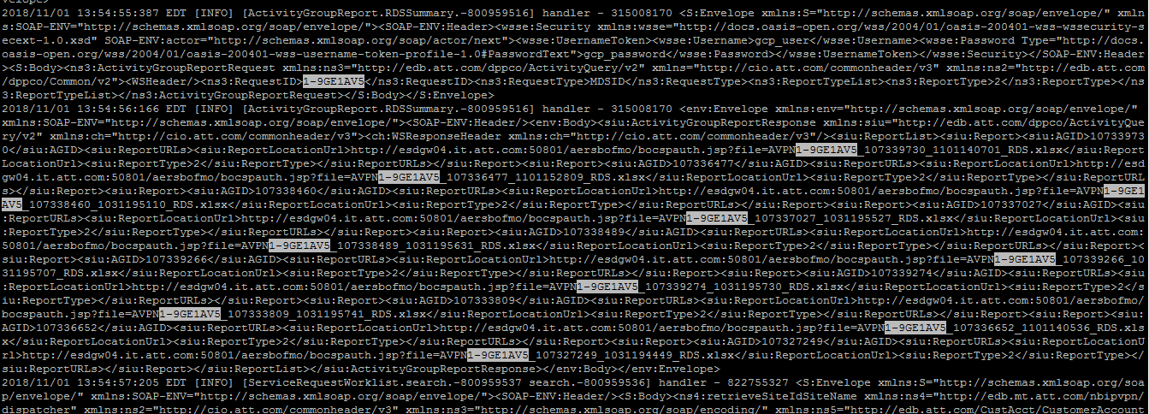

* **Today’s Logs:**

1. Enter the path under Prodsupp as:

* Cd /opt/project/log/ms/ws
* grep solution number *server*



1. Copy the handler file and enter as:

cat [file name] |less



1. Search for the order number as

/ order number

